Frontend Overview of the Project

Dynamic Component Design: Angular components are designed to fetch, display, and manage data seamlessly.

Responsive Design: The UI is optimized for various devices, offering a seamless experience on desktops, tablets, and smartphones.

Service Integration: Angular services fetch data from PostgreSQL tables via Django APIs, ensuring fast and efficient communication for GET and POST operations.

Enhanced User Experience: Clean layouts, intuitive navigation, and dynamic updates make the frontend user-centric and visually appealing.

**1. Landing Page with Home**

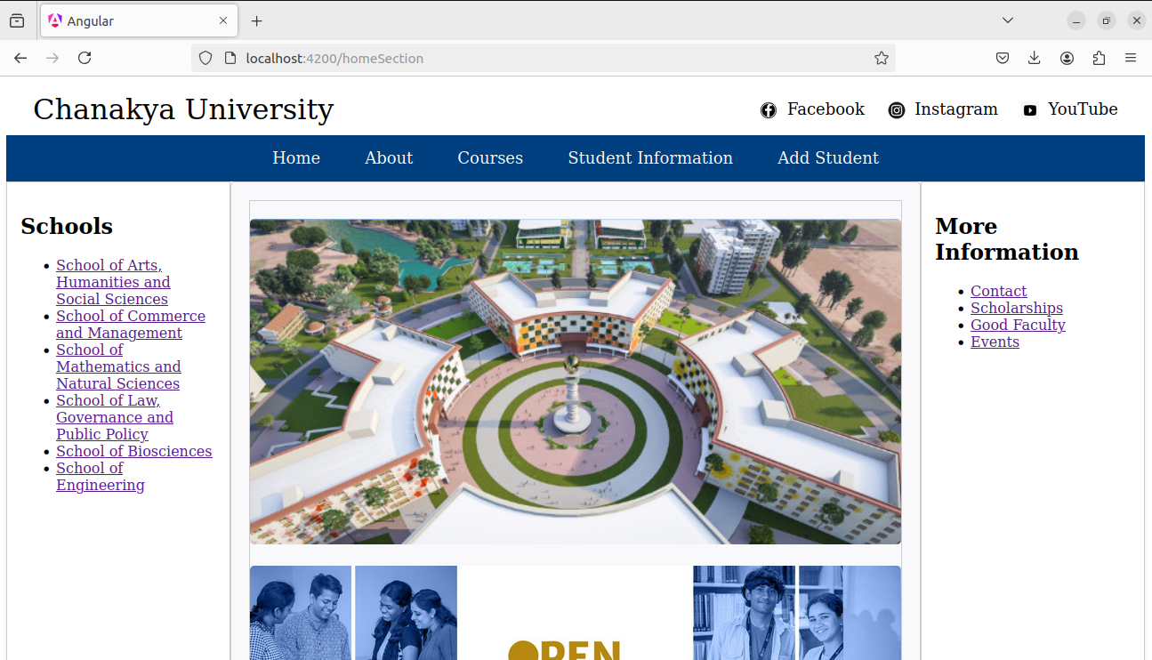

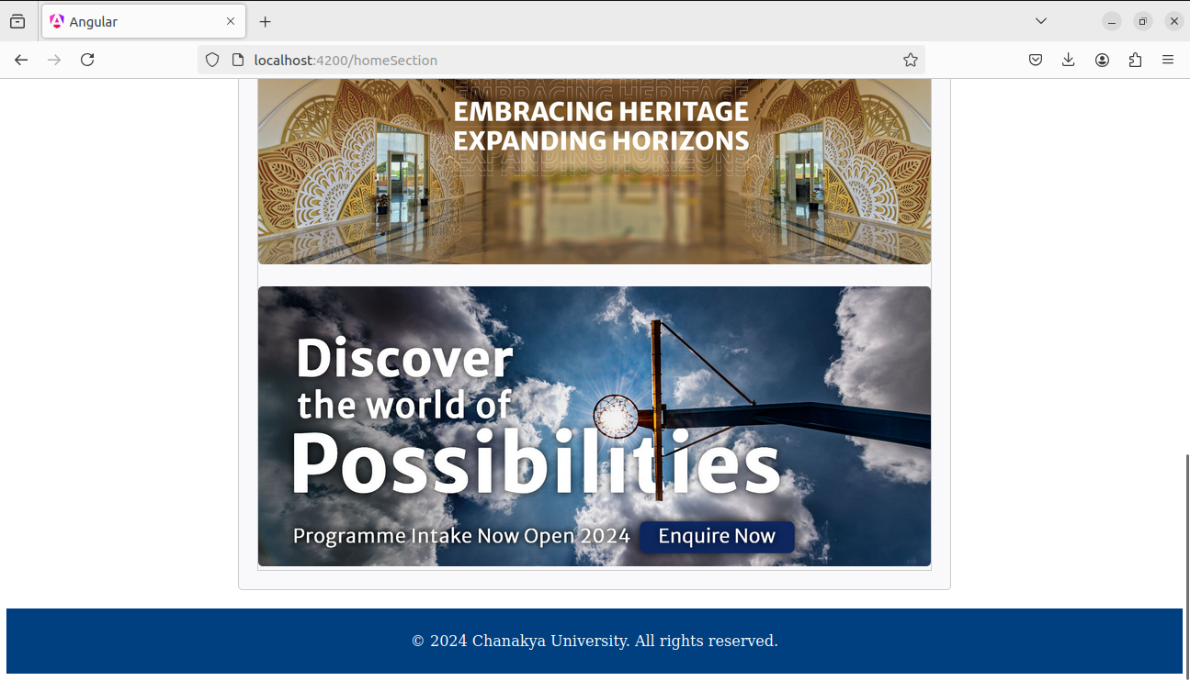

**2.About with breif information**

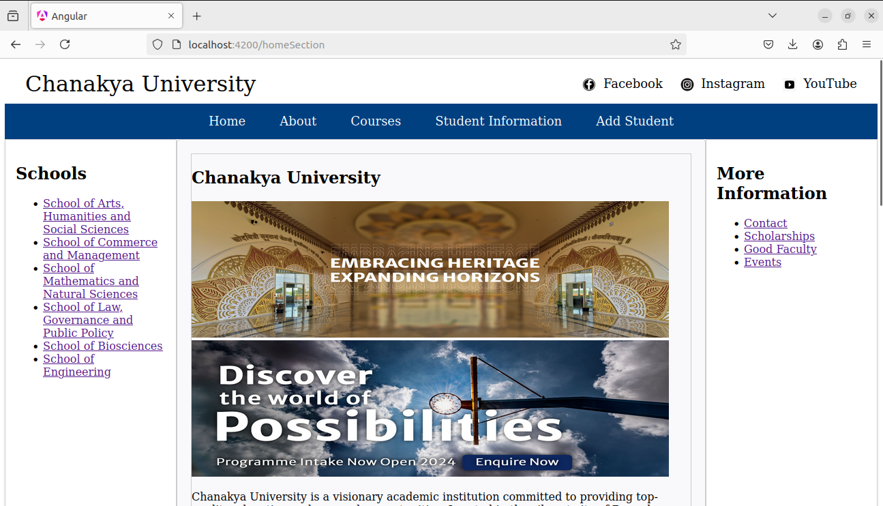

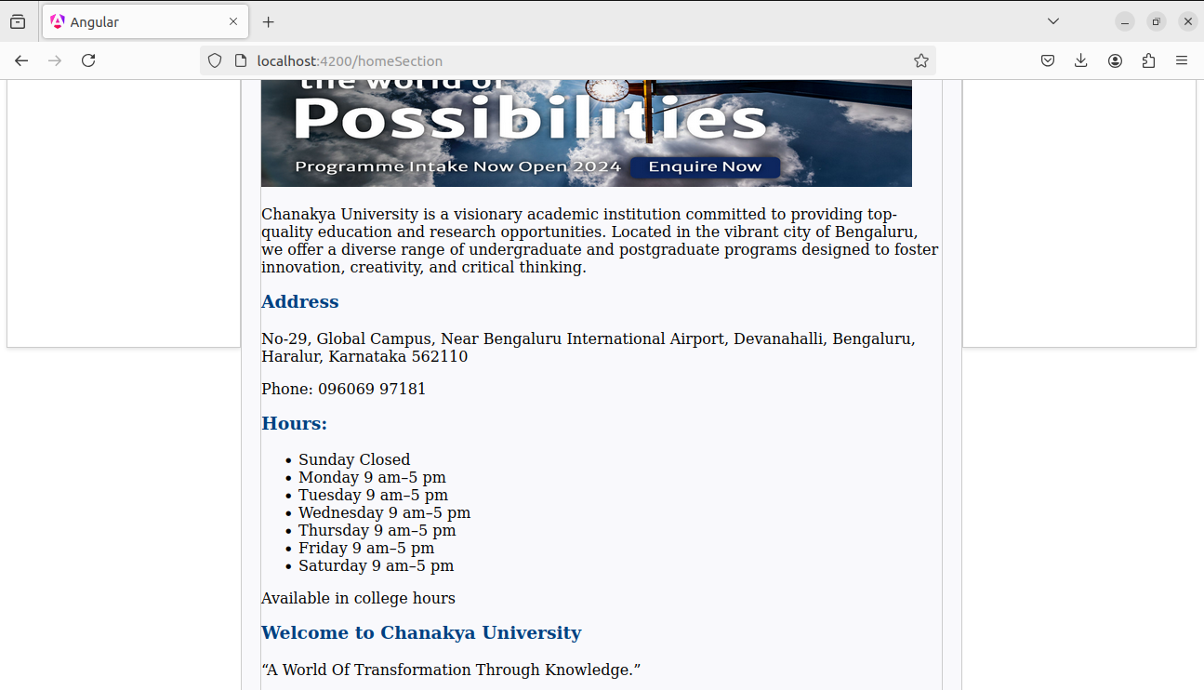

**3. Courses – by clicking on show UG Courses or show PG Courses we can see our postgress data by GET Method**

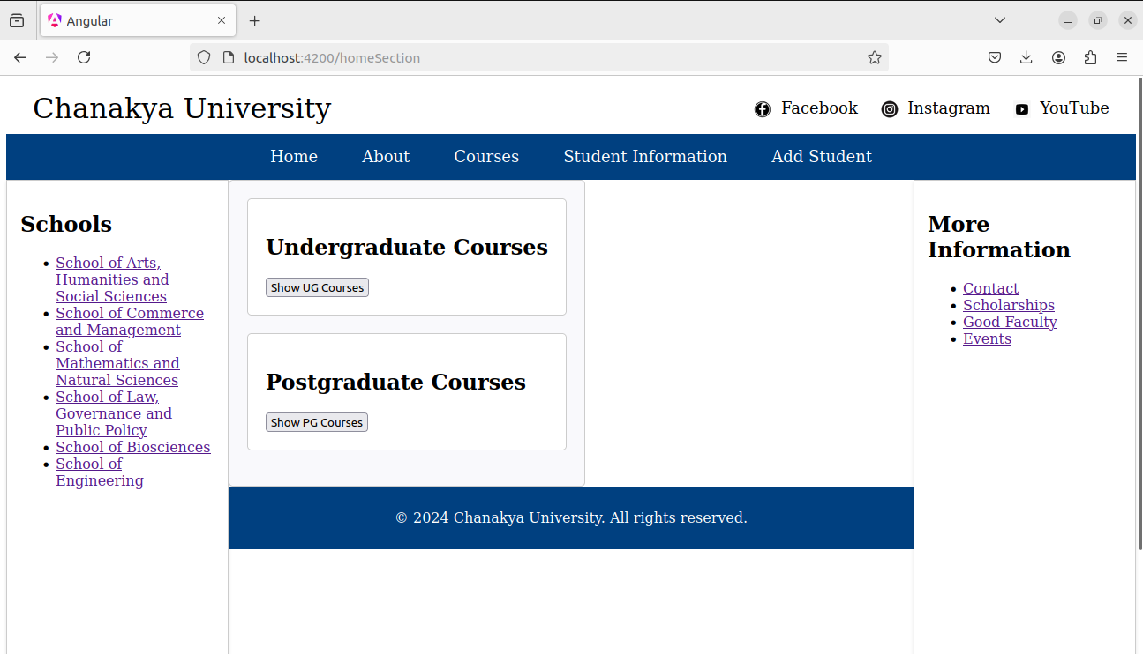

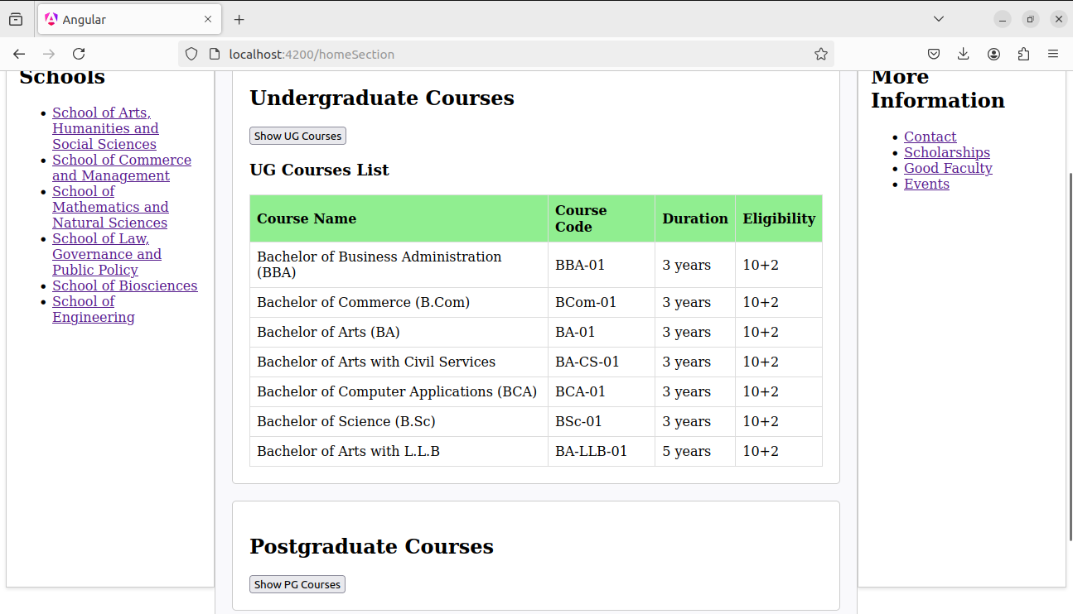

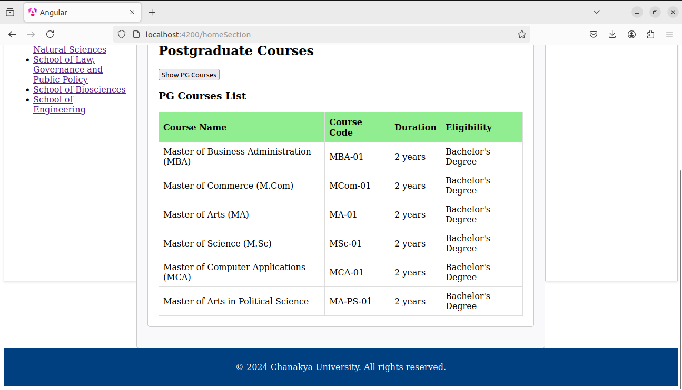

**4. Student Information**

It contains the student details by entering the particular student_id by using GET method

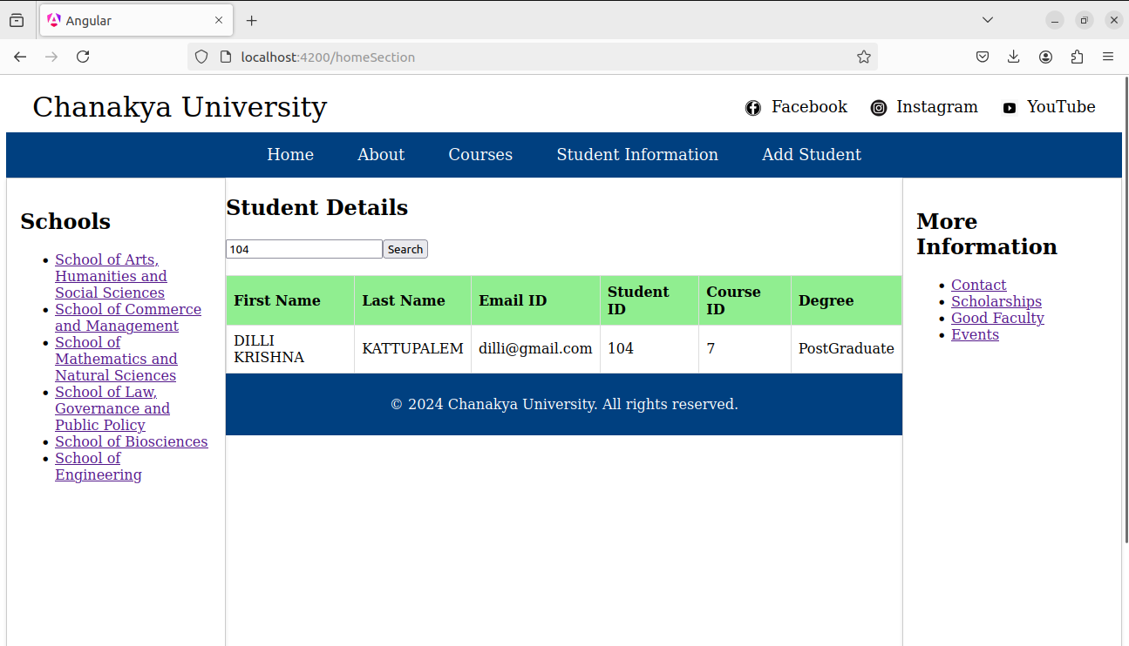

**5.Add Student**

**By this we can insert our data to our postgress table by POST Method**

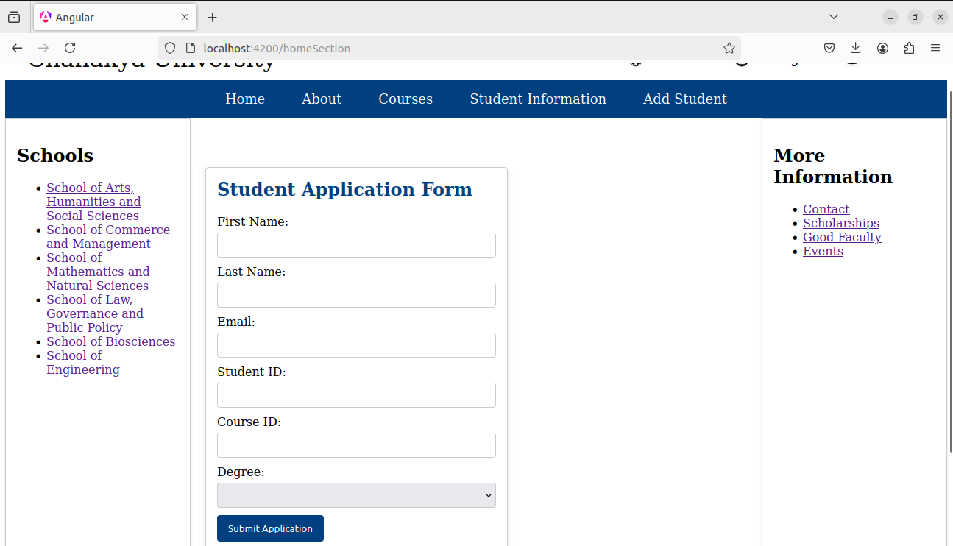

**By using Side bar links we can see our college details**